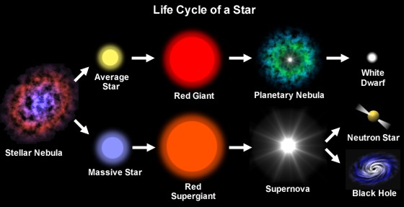Life Cycles of

What the star runs out of _______________ it turns into a Red Giant or supergiant star. Red Giants then have the energy to fuse _________ to create C______, N_________ and O________

What provides the energy for all stars to begin with?

fusion in red supergiants continues to larger nuclei due to the higher ____________ in the core;

Red Giants lack the mass to compress the core further at the end of the H_______ fusion, and they then shrink into________________which gradually cool;

As the gases get compressed due to gravity into smaller volumes the ________________ increases.

Stars

recall that fusion in large stars ceases when the core has been largely converted into I______ ___________and the star then explodes in a , leaving a dense _________ star or __________.