Prescription Drugs
Dr. Howard Chilcoat of the Johns Hopkins University School of Public Health and Hygiene in Baltimore discussed research into prescription drug abuse. Overall, he said, the number of people who abuse prescription drugs each year roughly equals the number who abuse cocaine-about 2 to 4 percent of the population. Whites are more likely than other racial or ethnic groups to abuse prescription drugs, and many people who abuse these drugs also have psychiatric disorders. Persons age 18 to 25 are more likely than persons in other age groups to begin abusing prescription drugs. Between the ages of 12 and 17, girls are more likely than boys to begin prescription drug abuse and are more likely to abuse stimulants and sedatives than other prescription drugs.
Dr. Kenneth Schmader of Duke University in Durham, North Carolina, said that the elderly (persons age 65 or older) represent about 13 percent of the U.S. population but consume one-third of all prescription drugs. These patients are generally less healthy than younger persons and often suffer from multiple diseases for which they take multiple drugs, Dr. Schmader said, and are therefore more vulnerable than younger patients to unintentionally misusing and becoming habituated to prescription medications. In one study of more than 1,500 elderly patients, 50 patients, roughly 3 percent, were abusing prescription drugs. In a study of consecutive admissions to a treatment program, 70 of 100 elderly patients admitted for prescription drug abuse were women. Eighty were dependent (that is, they experienced withdrawl symptoms if they tried to stop taking the drugs) on sedatives, 49 on opioids, and 3 on stimulants. Thirty-six were dependent on 2 drugs and 8 were dependent on 3.
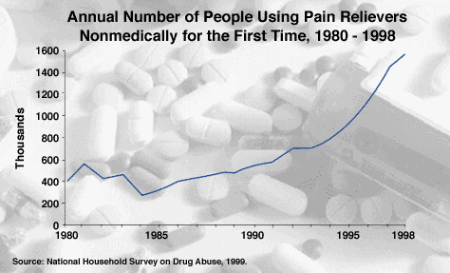In 1998 roughly 1.6 million people used prescription pain relievers nonmedically for the first time-four times as many as in 1980.
Dr. Richard Brown of the University of Wisconsin Medical School in Madison said that physicians' misunderstanding of the risks associated with prescription drugs can lead to inadequate treatment of some illnesses. Dr. Brown based his statement on research in which he and his colleagues asked physicians how they would treat a set of hypothetical patients who suffered anxiety disorders, pain associated with cancer, or back pain. The researchers gave the clinicians detailed profiles of the hypothetical patients that included a treatment history and characteristics, such as use of alcohol and history of substance abuse, related to possible misuse of prescription medication. The researchers compared the physicians' treatment plans with a plan developed by a panel of experts. Compared to the experts, the 2,000 physicians who participated in the study were more reluctant to provide opioids and less cautious about prescribing sedatives. For example, 5 percent of the respondents would not prescribe opioids for severe cancer pain and nearly, 80 percent would avoid opioids for severe, chronic back pain that had not responded to other treatments.
Dr. Steven Passik of Community Cancer Care, Inc., in Indianapolis, Indiana, discussed a study designed to evaluate the risks of misuse or abuse of drugs prescribed for management of chronic pain and to compare the risks with the drugs' benefits. The research involved 264 patients being treated with opioids for chronic pain not associated with cancer. On average, patients reported that the drugs relieved nearly 60 percent of their pain, and more than 90 percent said the pain relief made a significant improvement in their quality of life. Nearly 80 percent reported improvement in overall aspects of daily life such as mood, physical functioning, relationships, and sleep patterns. More than 60 percent of patients reported some adverse side effects from their medication, but only 1.2 percent described the side effects as intolerable. Overall, roughly 6 percent of patients (or their physicians) reported abuse or misuse of prescribed drugs. Drug abuse issues in pain management are complex, Dr. Passik said, but his study results suggest that the risk of opioid abuse is low compared with the benefits of the drugs in chronic pain management.

Questions
- What percentage of the population abuse prescription drugs?
- Which groups of people are more likely to abuse prescription drugs?
- Which group is most at risk to unintentionally abusing prescription drugs and state why
- What statement did Dr. Richard Brown make about physicians (doctors) and prescription drugs
- What evidence did he gather to support this statement
- Dr. Steven Passik carried out a study to ‘evaluate the risks of misuse or abuse of drugs prescribed for management of chronic pain and to compare the risks with the drugs' benefits’

- State what was good points found in the study
- State the bad points found in the study
- What conclusion was made by Dr. Passik

